**FINAL WEB DESIGN REPORT**

**December 10, 2018**

**Siying Tang (1155111650)**

1. **Introduction**

Web design is entering a new era as the advent of big data has driven web development into a more user-based process. With efficient data analytic tools in the market, designers can explore potential problems and develop solution plans through design thinking process by constructing the five planes of user experience.

Therefore, based on what I have learnt, I am trying to adopt design thinking to develop a hair care website. In order to better understand target users’ needs and provide most useful information, the five planes of user experience are used as the framework throughout the whole website development process. In the following sections of the report, each plane will be explained in details to illustrate my purpose and idea of the website.

**2.0 Strategy Plane**

**1) Site Objective**

The initial idea of my web project starts from the phenomenon I have noticed for recent years. I have found that more and more young people are troubled by hair-loss problem. Not only did my undergraduate and postgraduate classmates were searching for solutions for hair problem, but also my young sisters, brothers and many other relatives were distressed by hair-loss phenomenon.

As a result, I was thinking and asked myself questions like “can I design a website to solve the specific problem and help those people? What could be the information they need?” On the basis of my contemplation, I have come with a clear objective, which is to provide useful information to help people who are confronting with hair-loss problem.

**2) User Needs**

After the goal was set, I have conducted a research to figure out the exact needs of my target users. Basically, my research comprises of two steps. Firstly, I designed an online survey to collect basic data of potential users, including age, gender, job, personality, habitual residence, specific type of information they need, etc. Secondly, one-on-one interview has been conducted to further conclude the details of what my target users are concerned about. In this step, I have asked three friends in CUHK, who come from new media program, geography politics in greater China program and Chinese studies program respectively, and two relatives including my uncle and young sister. In total, five persons have been interviewed about their daily hair care habits and problems they concern most.

According to the result of the online survey and one-on-one interview, I summarize the user persona as follows (see **Figure 1**).

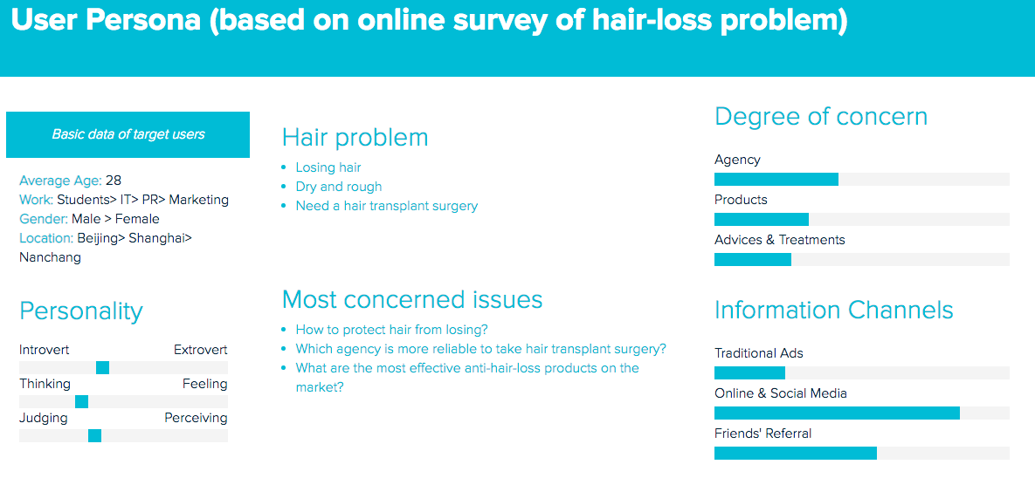

*Figure 1*: *User Persona (based on online survey of hair-loss problem)*

1. Basic characteristics

The result shows that my target users have an average age of 28. Most of them are students and people who work in the IT, PR and marketing industry. Men are more vulnerable to hair-loss problem. And people living in Beijing, Shanghai and Nanchang are more concerned about their hair.

1. Personality

According to the research, target users are most likely to be introverts who rely more on thinking than feeling as well as judging than perceiving. Therefore, it can be inferred that potential users are the type of people who are rational and believe in truth and statistics.

1. Hair problem

The most frequently mentioned problem is hair losing, followed by hair quality and transplant surgery.

1. Most concerned issues & Degree of concern

Based on the score people gave, the most important problem is “which agency is more reliable to take hair transplant surgery?”, followed by “what are the most effective anti-hair-loss products on the market?” and “how to protect hair from losing”. These results have great influence on the basic functions of the website.

1. Information channels

It is easy to see from the result that people rely more on online social media than friends’ referral and traditional advertisements when they seek for information about hair care problems. Therefore, a website that provides professional information and suggestions about hair problem should gain popularity among target users.

Based on the user characteristics, I further generated the user journey map of how they will engage with my website as follow (see **Figure 2**).

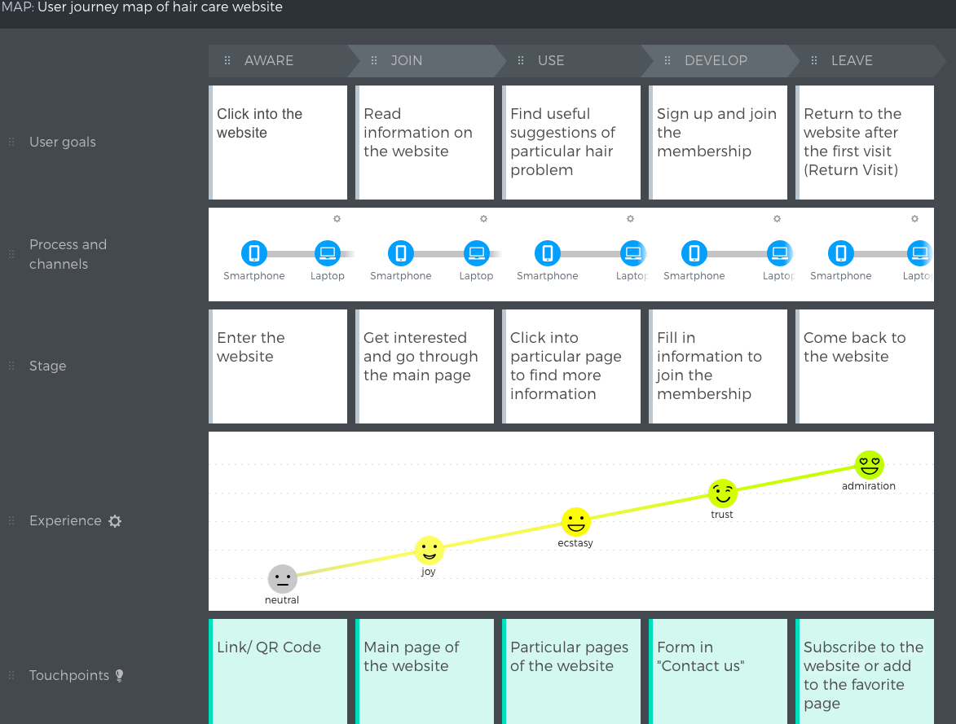

*Figure 2*: *User journey map*

**3.0 Scoping Plane**

Grounded on the objectives of my website and users’ characteristics as well as the user journey map, I sketched a list of functions that I planned to place on my hair care website.

**3.1 Function Specifications**

1. Clear website name

As the first and foremost step of user journey map is to let users click into the website and go through the main page, a clear and eye-catching website name is needed to retain users. Otherwise, they would be confused or bored and leave the website immediately. Therefore, I named my website as “Your Hair Guardian”, which is “你的頭髮守護天使” in Chinese.

1. Easy-to-follow navigation bar

A simple navigation bar is placed on the top right for users to go directly to the sections about hair care issues which they want to know more.

1. Featured buttons on navigation bar

Based on the users’ degree of concern of hair-loss issues which has been discussed in previous section of online survey and one-on-one interview, four featured buttons are added into the navigation bar, except for the main page, including “Hair transplanting agency”, “Product reviews”, “User discussion forum” and “Contact us”.

1. Charts and visual data

As Professor Bernard always mentions, data should be demonstrated to target audiences in a more user friendly way. Therefore, line graphs and bar charts are frequently used in the “Product reviews” and “Daily hair care suggestions” pages of the website to help users compare different options and make choices.

1. Airtable as Backend

Since one of the mission of the website is to encourage viewers to sign up and join the membership, it is very important to use a powerful platform to collect and store user data. After learning for the whole semester, I would like to say that Airtable is truly the most powerful data management tool I have ever used. Therefore, I choose it as the backend to store user data of my website.

1. Maps

Because the most concerned issue of my target users is which agency is more reliable when they want to take a hair transplant surgery, I try to offer as much detailed information of different agencies as possible for them to make choices. Among all the information I provide, location should be an indispensable part as it greatly affects users’ decision making process. Thus, I provide routes and responsive maps in the “Hair transplanting agency” page.

1. Responsive design

As we are living in the mobile age, it would be very possible that users like to browse my website on mobile phones and iPad or other tablet PC instead of using computer or laptops. So my website is responsive designed to provide good user experience on screens of different sizes.

**4.0 Structure Plane**

To provide sufficient information, multiple pages are used in my website. Therefore, in order to generate well-organized content, I have built a site map to detail the structure of my website through information architecture (see **Figure 3**).

In the site map, five basic sections constitute the first level of navigation bar: Home, Agency, Product, User Forum and Contact Us. Moreover, two subsections are included in “User Forum” section; one is “Daily Hair Care Suggestions”, and the other is “User Community”.

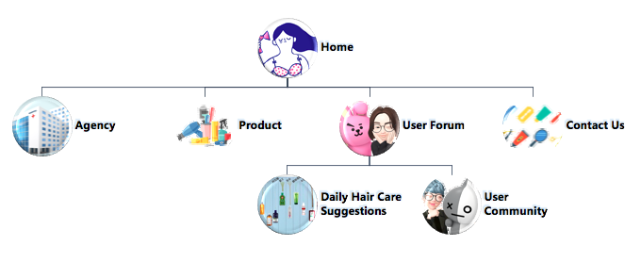

*Figure 3*: *Site Map*

**5.0 Skeleton Plane**

On the basis of the site map, I have sketched a basic wireframe for the website to develop the layout and user interface. In all, six pages are used to display the content, including Home, Agency, Product, Daily Hair Care Suggestions and User Community (belonging to User Forum section) and Contact Us page (see **Figure 4-9**). As mentioned in Scoping plane, seven specific functions have been applied in relative pages.

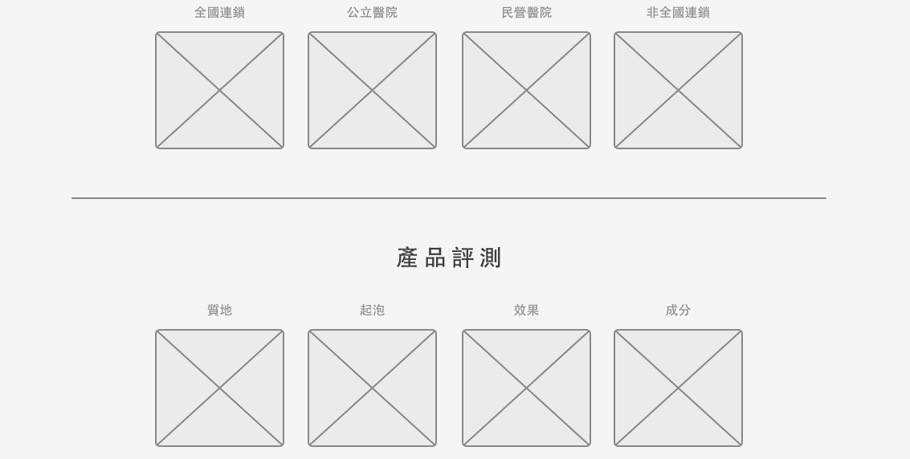

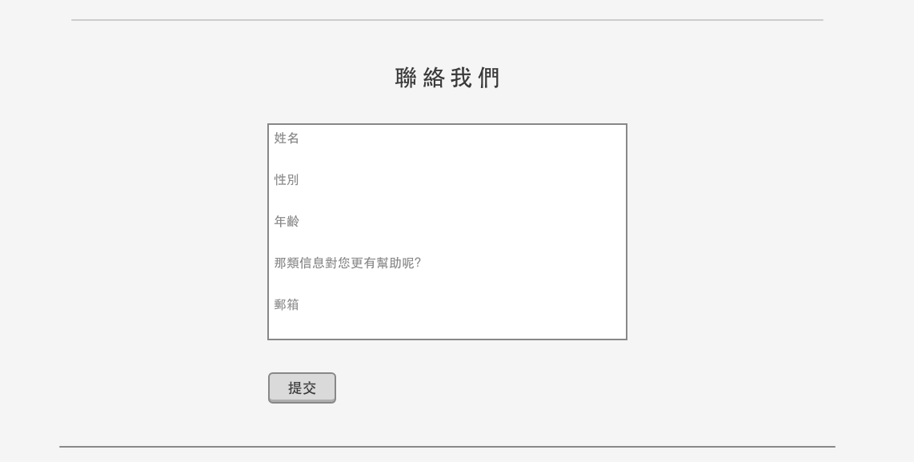

*Figure 4*: *Main Page*

Once users click into the Agency page, they can see four pictures representing four different types of agencies. The words above each pictures are clickable, which will lead users to pages that introduce the most recommended agencies of each type.

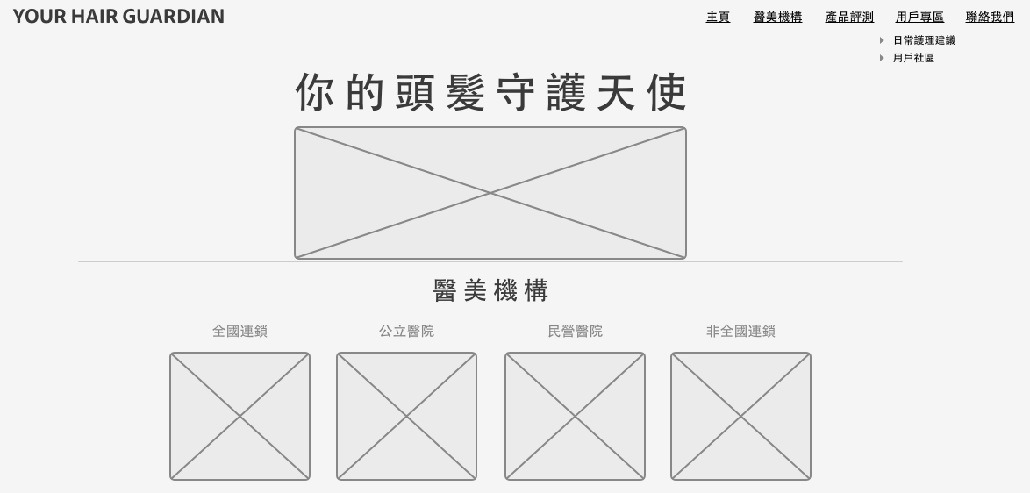

*Figure 5*: *Agency Page*

Same as the demonstration of Agency page, the Product page also provides four pictures indicating the quality, bubble, effect and ingredient of popular anti-hair-loss products. Users can click into each section to view detailed information with charts and graphs.

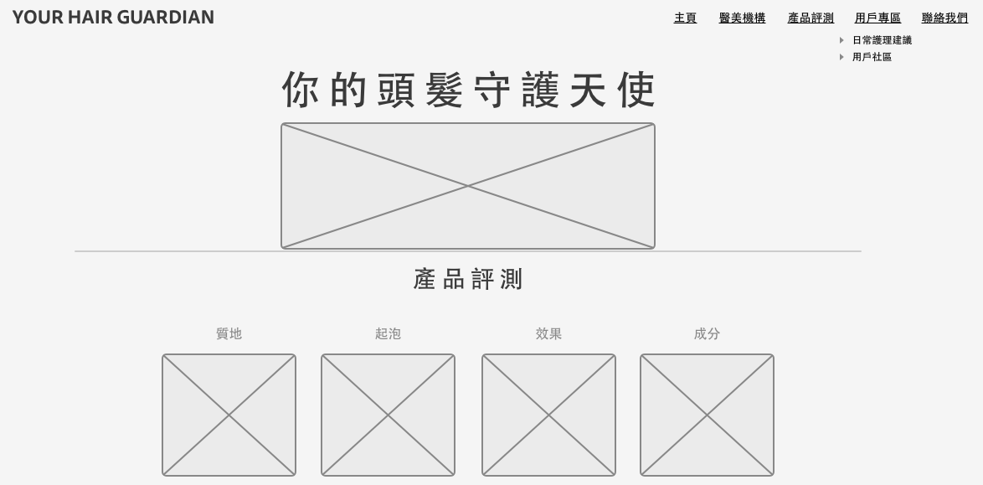

*Figure 6*: *Product Page*

“User Forum” page has been divided into “Daily Hair Care Suggestions” and “User Community”. Bar charts will be used to show the frequency of methods used to protect hair from loss.

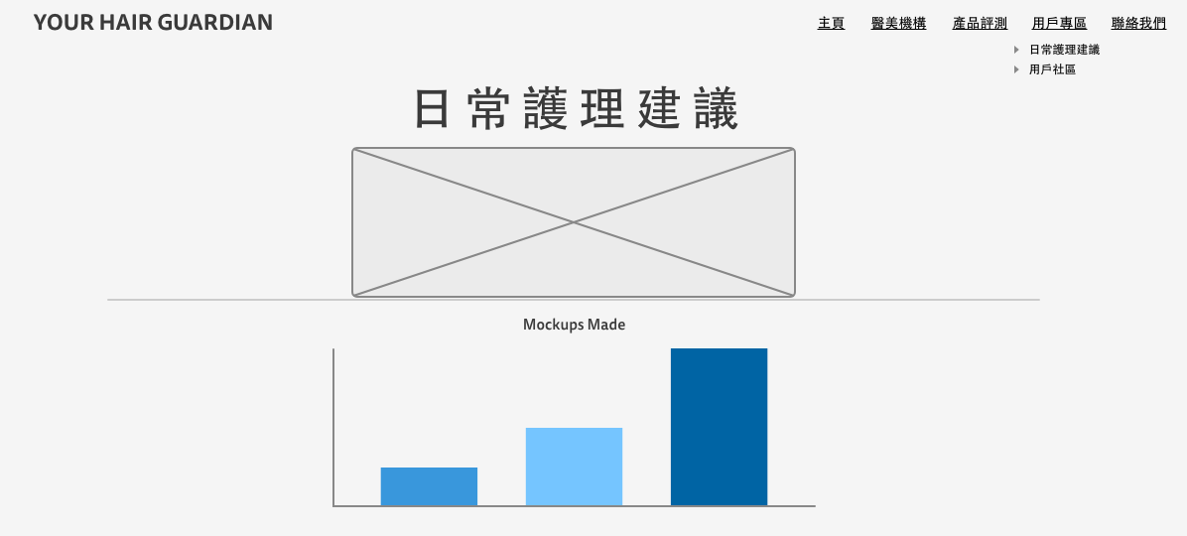

*Figure 7*: *Daily Hair Care Suggestions Page*

On the User Community page, viewers can not only see others’ experience and useful suggestions, but also are free to leave comments or questions on the message board. 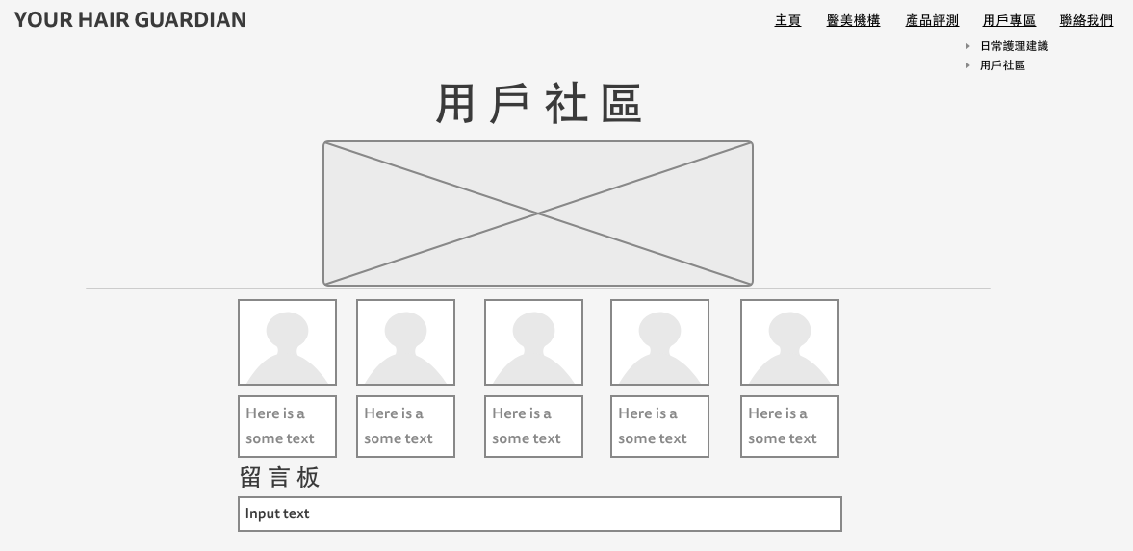

*Figure 8*: *User Community Page*

The Contact Us page functions as a platform for users to sign up as the VIP member of the website. Basic personal data will be collected through Airtable form embedded into the page.

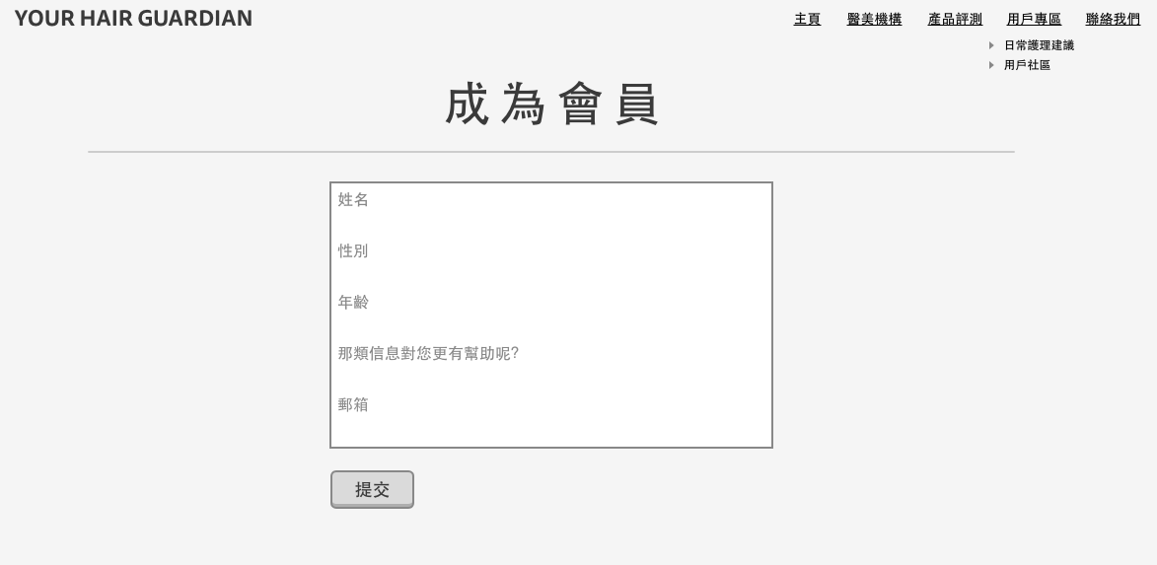

*Figure 9*: *Contact Us Page*

**6.0 Surface Plane**

After determining the goals, identifying users’ need and building ideal prototype, I could finally apply the coding skills I have learnt into use. As the user persona suggests, my target audiences are inclined to be rational and data-oriented. Thus, my website is designed in a simple and functional way to show the most important data. Pictures only appear when it is necessary. Here are the screenshots of my website (see **Figure 10-16**).

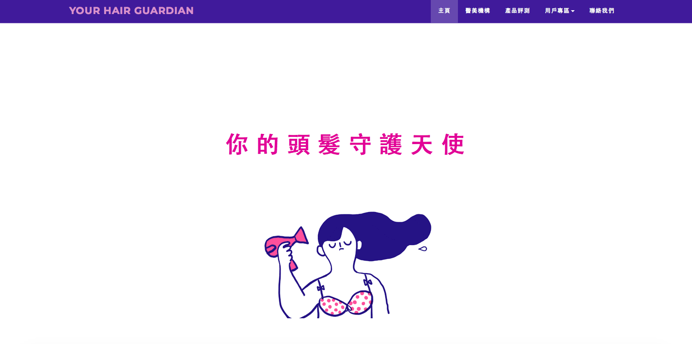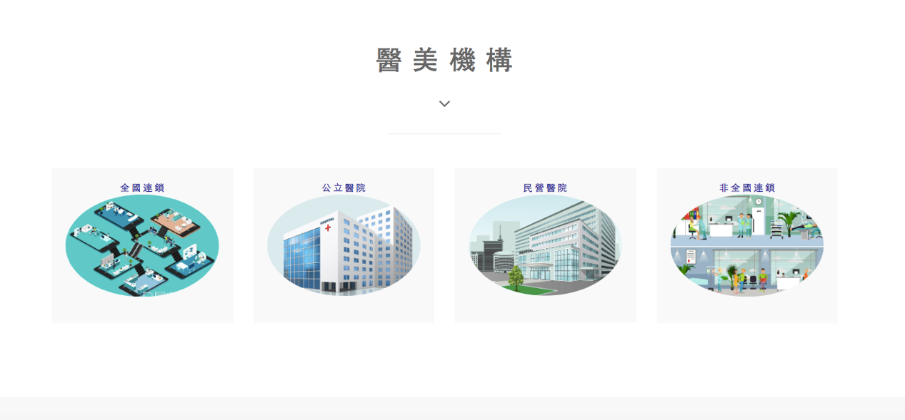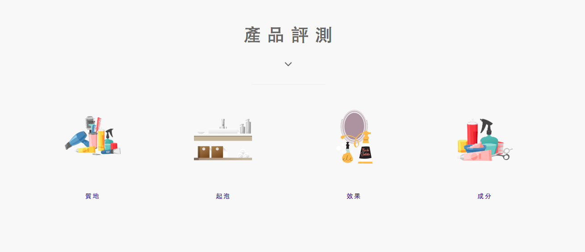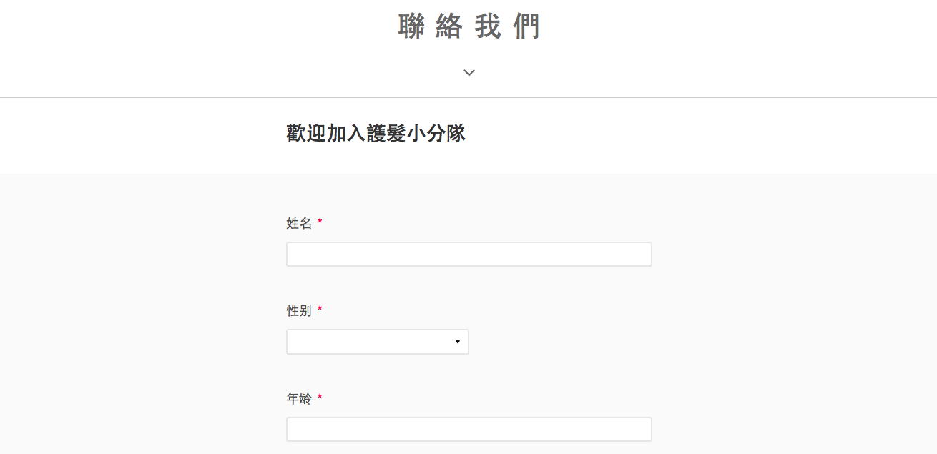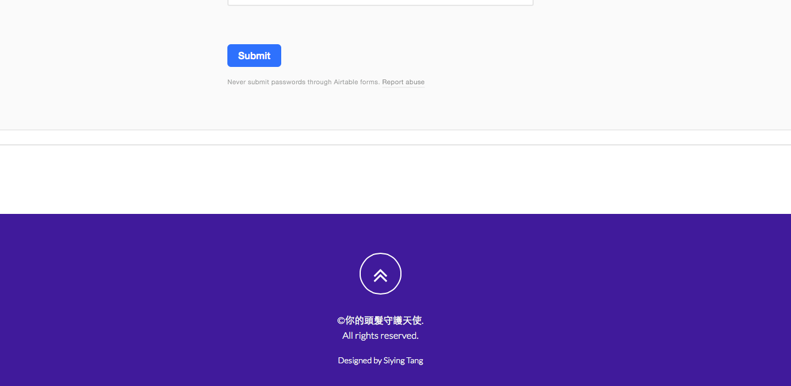

*Figure 10*: *My Homepage*

As for Agency page, “全國連鎖” demonstrates four well-known chain agencies. Users can get useful information by reading the instructions of each agency and directly consult or make appointment with the ideal one though the link under the instruction. So does the “非全國連鎖” displays.

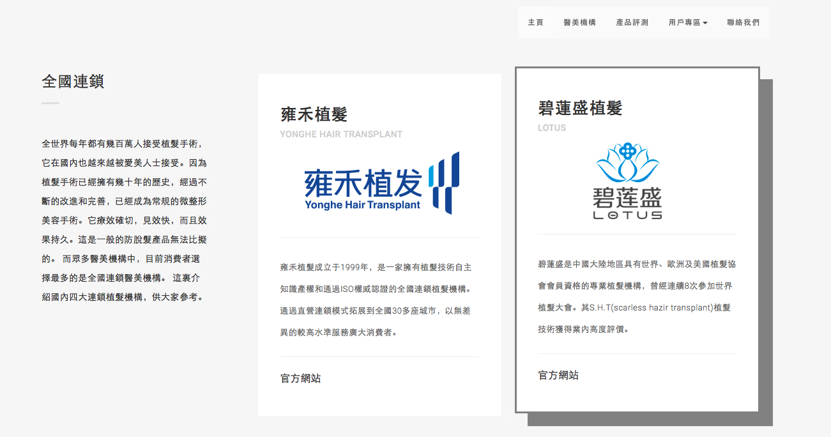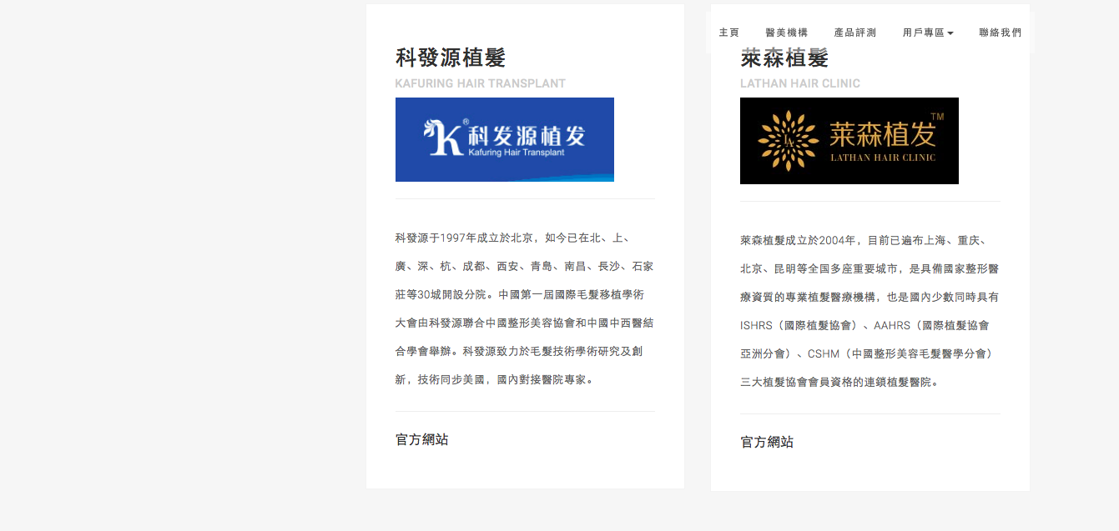

*Figure 11*: *“全國連鎖” Page*

Beceuse seldom does pubilc hospitals provide hair transplanting surgery, only two of them are famous. As a result, the website provides detailed maps and routes for users to decide which one to go. Once users click the name of the hospital, map will appear with route guidance. So does the “民營醫院” page displays.

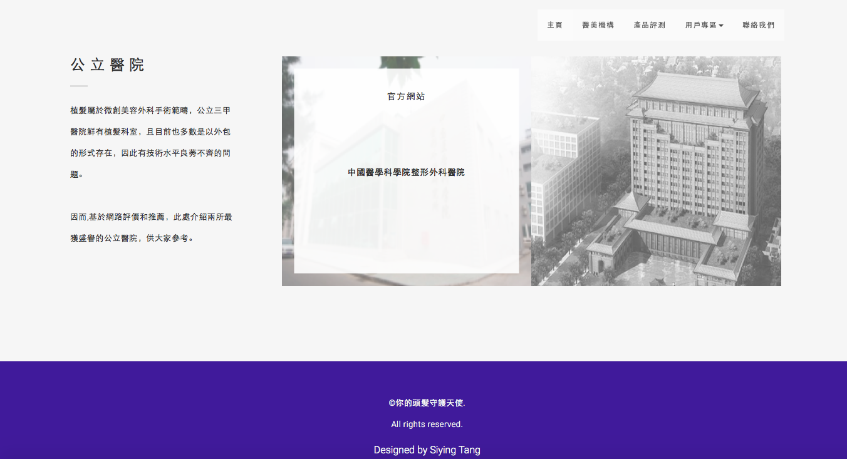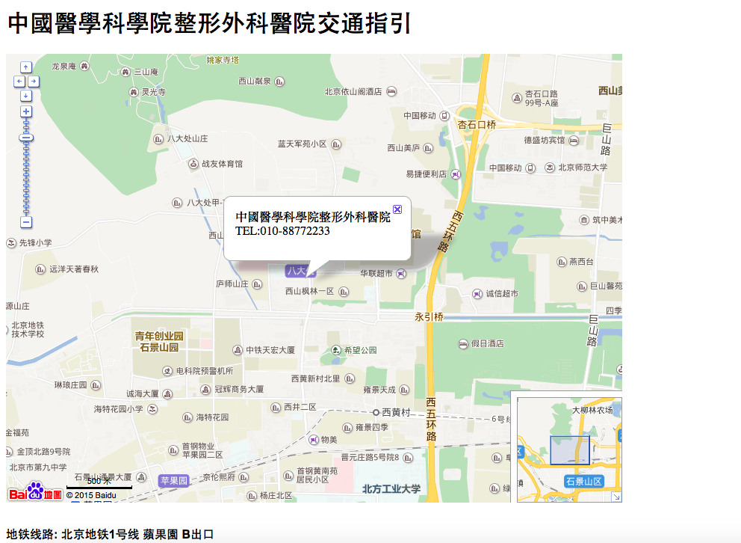

*Figure 12*: *“公立醫院” Page*

For Product page, line graphs and bar charts are used in four sections of product reviews to provide users with direct visualized data of each brand. Here are two examples (see **Figure 13**).

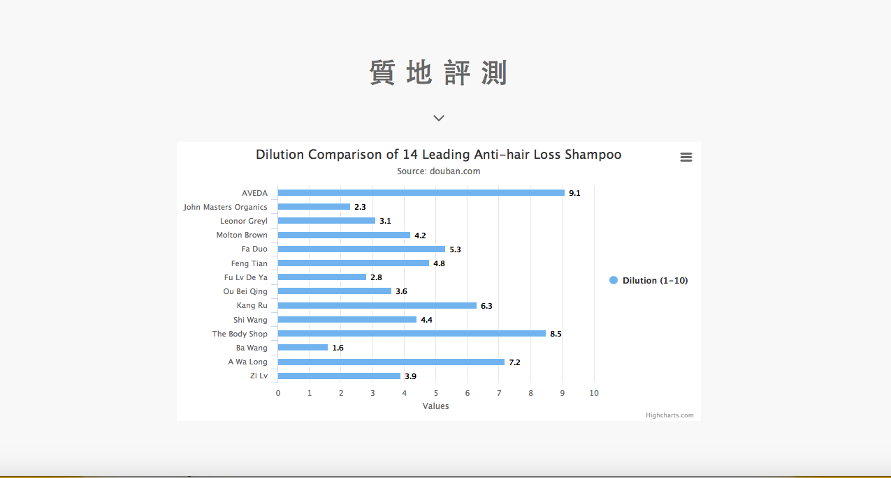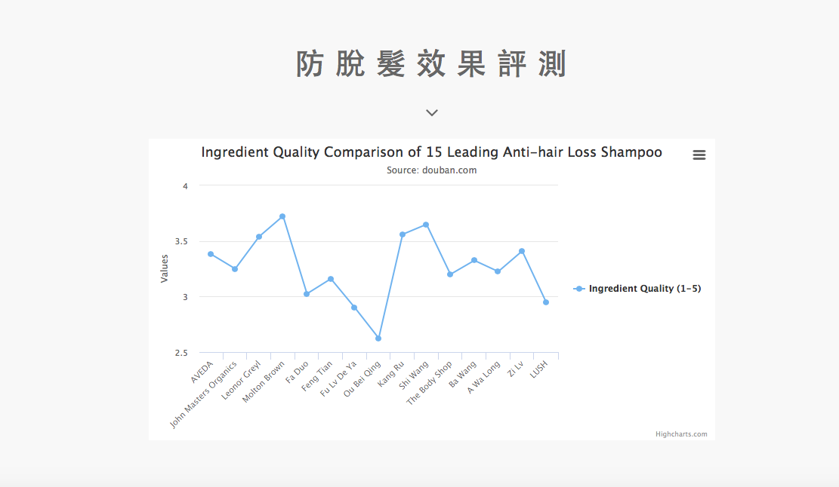

*Figure 13*: *Two Examples of “產品評測” Page*

Bar chart is also used in Daily Hair Care Suggestions page to provide viewers with comparable data (see **Figure 14**). In User Community page, some users have shared credible advices based on their personal experience (see **Figure 15**). Registered users can interact with them by leaving comments or asking questions through message board (see **Figure 16**).

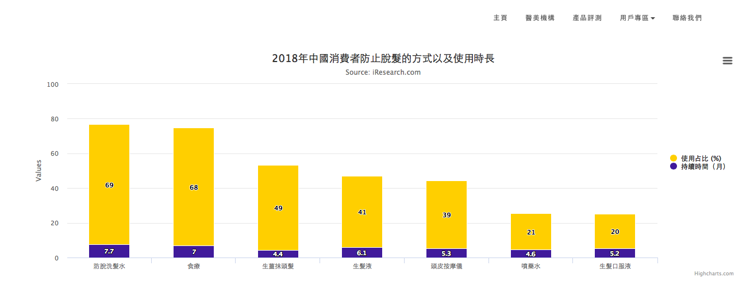

*Figure 14*: *Bar Chart on “日常護理建議” Page*

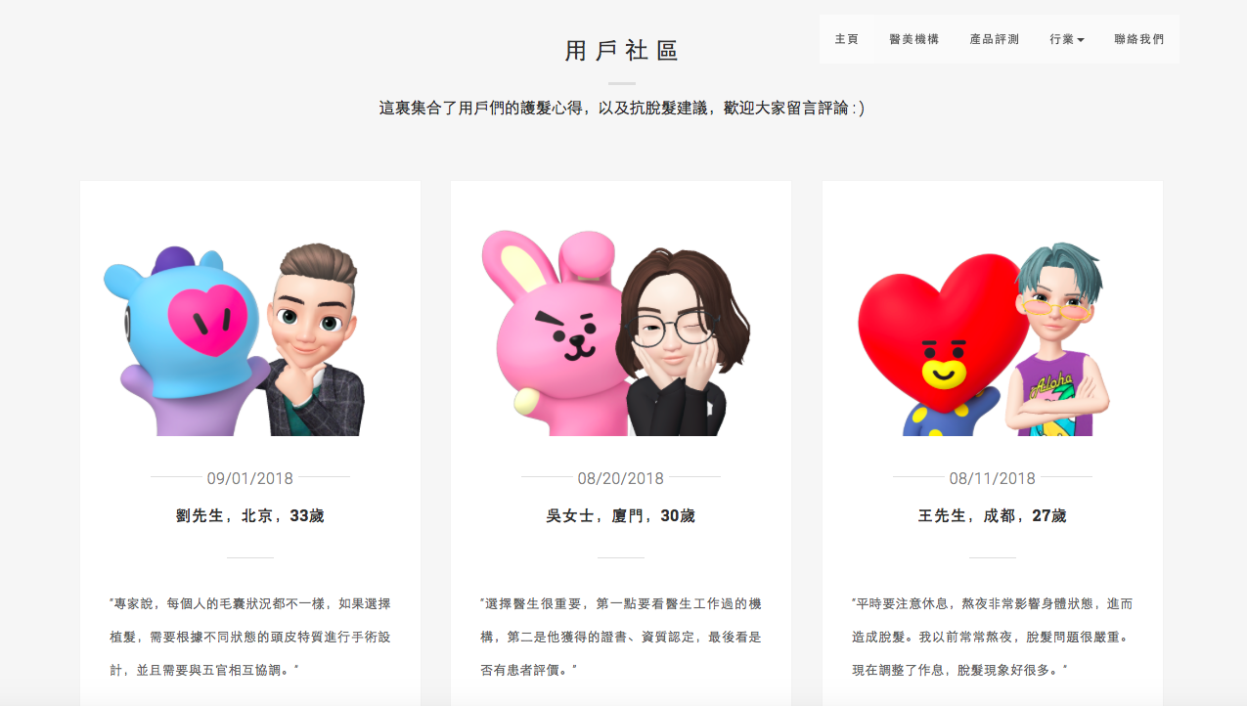

*Figure 15*: *Content shared on “用戶社區” Page*

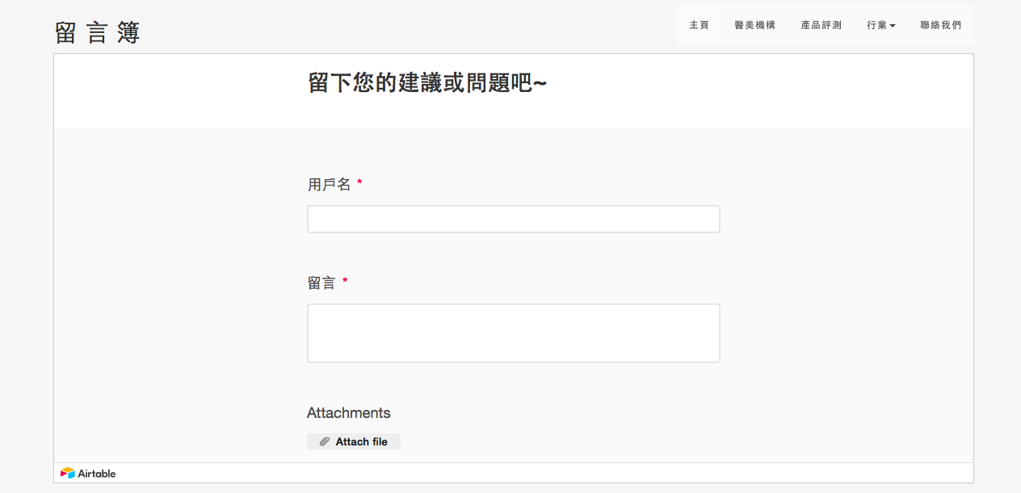

*Figure 16*: *Message Board on “用戶社區” Page*

**7.0 Website Test**

After finishing the visual design of the website, I finally came to the last part of design thinking process: Test. Both qualitative and quantitative methods are adopted to detect problems of the design, so that adjustments can be made to improve the usability of the website. For qualitative test, I adopted usability test to examine whether my website provide appropriate information and whether it is easy to use. While for the quantitative test, A/B test is conducted through Google Analytics, as well as a dashboard comprised of detailed statistics of website page views, viewers’ characteristics, user behaviors and so on.

**7.0 Usability Test**

To conduct usability test, I still invited the five persons who have been interviewed in the first stage, including three friends in CUHK from new media program, geography politics in greater China program and Chinese studies program respectively, and my uncle as well as my younger sister. The test was conducted both on laptops and mobile phones.

The test takes two steps. In the first step, I invited them to browse my website casually, and tell me their opinions whenever they felt uncomfortable or good. During this stage, I took down some notes to record their behaviors and comments. In the second step, I asked them to evaluate the website by telling me their willingness to sign up as the membership. Overall, the test took around 6 minutes for each participant on two devices.

Below are the results of the first step of the usability test as well as the adjustments I had made.

|  |  |
| --- | --- |
| Problems | Adjustments |
| The main picture on the homepage is not attractive enough | Change the static picture into a dynamic one  (from jpg. to gif.) |
| Cannot go back to the main page after entering to a subpage | Add links to the buttons on navigation bar  (make buttons clickable) |
| Want to see photos of product reviews | Add photos to compare all the selected products |
| Responsive problems to small screens like mobile phones | Adjust the responsive design |

*Figure 17*: *Problems and Adjustments of Usability Test*

In the second step, I received the answer “Yes, I am willing to sign up and join the membership of the website” for four times out of five. My younger sister rejected to sign up because she thought VIP member should enjoy some privileges, such as discounts on products or hair transplanting surgery. Right now, it was not that alluring for her to sign up. This problem is a little bit difficult to solve as I haven’t contacted the agencies and companies showed on my website yet. I will give it a try if the website is successful in the future and enjoy some popularity among users.

**7.2 A/B Test**

As I have changed the static picture on the home page into a dynamic one according to the result of the usability test, I wonder whether it will help me to retain users or not. Thus, the basic objective of the A/B test on my website was to figure out whether users are willing to stay in my home page with a dynamic picture or not. So I created a vibrant version B with the GIF image compared to version A with JPG image. Bounce rate of landing page was used to evaluate the result.

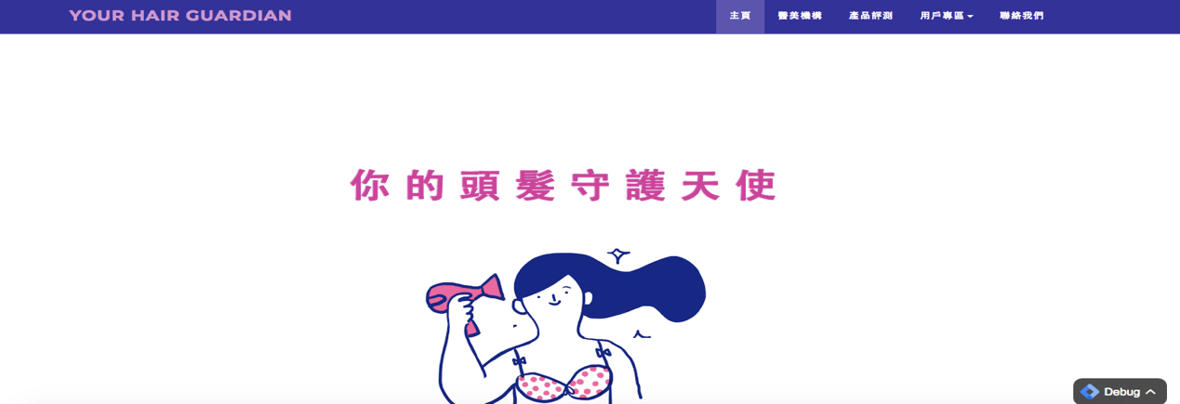

Static Picture

Jpg.

*Figure 18*: *Version A*



Dynamic Picture

Gif.

*Figure 19*: *Version B*

The result shows that Version B indeed has relatively lower bounce rate of landing page than Version A, which is 20.68% to 22.15% (see **Figure 20**). Therefore, I decide to use the GIF image instead of the JPG one.

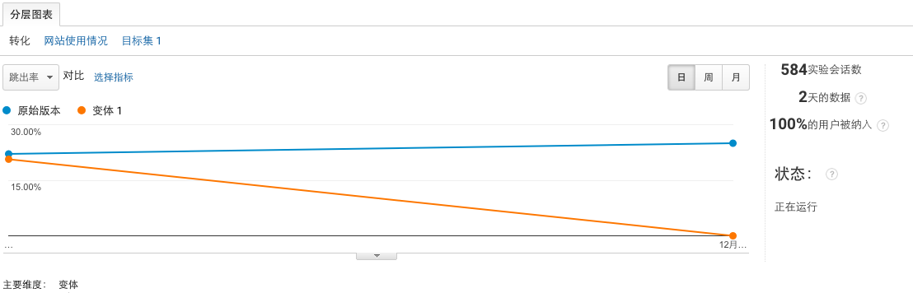

*Figure 20*: *Result of A/B Test*

**8.0 Measuring the performance through Google Analytics & Airtable**

In order to measure the performance of the website, I used Google Analytics to generate detailed report to see whether I am moving in the right direction to achieve my goal.

First of all, I created a dashboard on Google Analytics to see how my website is being used from Dec 4, 2018 to Dec 10, 2018 (see **Figure 21**).

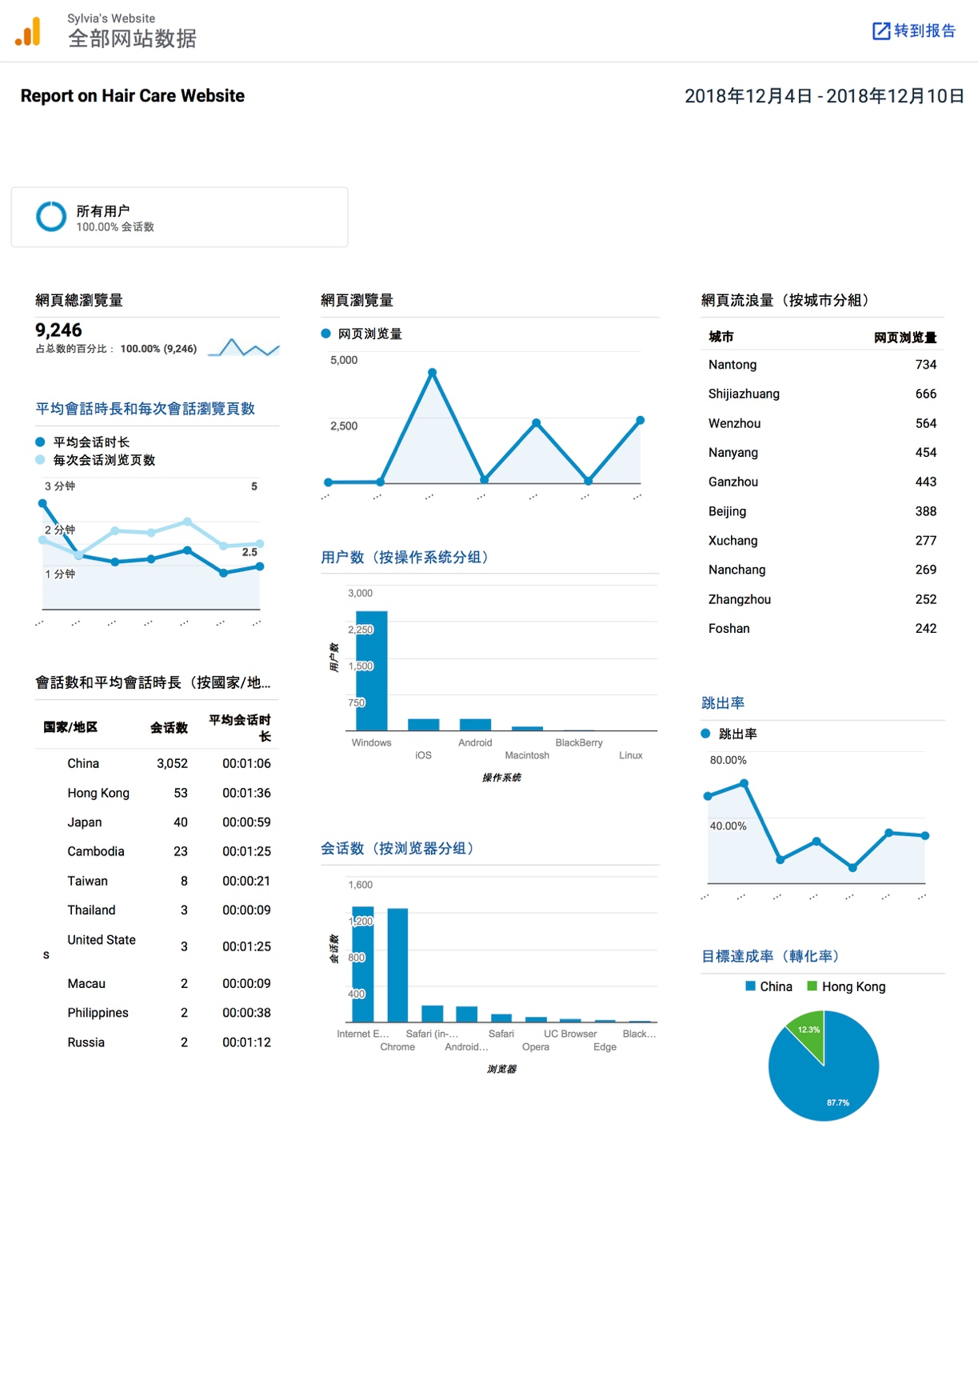

*Figure 21*: *Google Analytics—dashboard*

1. Page view

The report indicates that the overall page view of the website reaches 9246 throughout the 7 days. On Dec 6, the number reaches its highest point as 4211. Perhaps it is because I have posted the link of my website on multiple social media platforms including Wechat, Weibo, Ins., Facebook, etc. on that day.

Besides, I have also generated a form to calculate the total page view of users in different cities, for I would like to further develop my website to sale some hair-care products, and regions of my potential customers are of great importance to evaluate the market. As a result, Nantong, Shijiazhuang, Wenzhou, Nanyang and Guangzhou are the top 5 cities where residents are relatively more concerned about hair problem.

1. Session number and session length

As the graph shows, both the average session length and session number have seen a decline from 0:02:25 to 0:01:00, and 2.65 pages to 2.50 pages. Perhaps the website need to add more elements to keep users remain on the pages and click buttons to see more.

Moreover, in order to test whether the session number comes from my target users as predicted, who are young people facing hair loss problem in China, I also generate a form to show session number and average session length of different counties and regions. The result is in accordance with my prediction, as China occupies the highest session number. However, it is interesting to find that users in Hong Kong spend longer time on my website than those in mainland China. Perhaps the style of the website is more function-oriented, which caters to the taste of Hong Kong users.

In addition, I classify the session number according to different browsers to better understand users’ habits. The result indicates that Internet Explorer enjoy almost the same popularity with Chrome. While other browsers are far less welcomed by my target users.

1. Number of users classified by operation system

It is a surprise for me to find that most of my users use Windows as the operation system, which reaches 2475, while the numbers of iOS and Android are almost the same as 266 and 265. It is totally opposite to my estimation. Therefore, I guess that perhaps people click into my websites during work time, so most of them still use computer or laptop instead of mobile phones.

1. Bounce rate

It is delightful to find that the bounce rate shows a downward trend on the whole. As least, more people pay certain interest to my website rather than just leave the page after the click.

1. Conversion rate

I have set a specific goal to measure the performance of my website, which is the number of click on Contact Us page. Because I want to collect basic data of users to further develop my website, I expect them to click into the Contact page and fill in the information to generate user data. The result shows that 87.7% of the clicks come from Mainland China, and 12.2% of them pay a return visit to my website.

As the goal was set on Dec 9, 2018. Therefor the data only shows the one-day conversion rate. Overall, on Dec 10, 57 out of 2400 people entered the Contact page, which is not a satisfying result (see **Figure 22**). More efforts should be put to attract users to sign up, such as providing them with discount on products and services just as my younger sister mentioned about in the usability test.

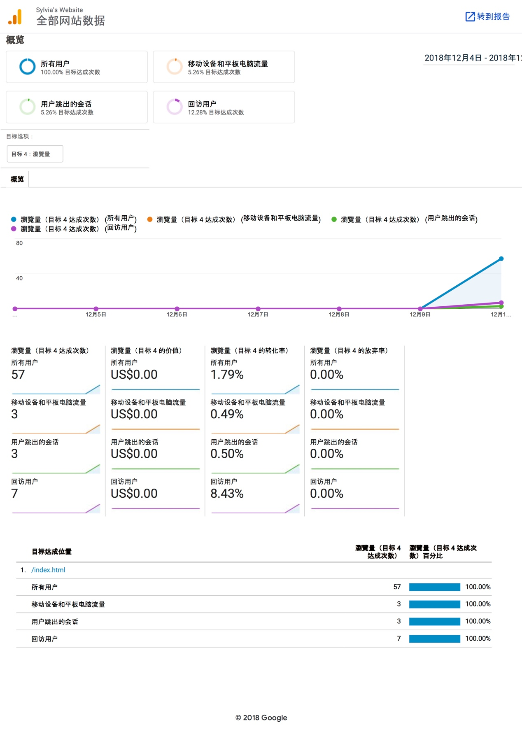

*Figure 22*: *Google Analytics—Conversion Rate*

Except for Google Analytics, Airtable has been used as a powerful tool to manage user data I have collected. The final result shows that there are 105 people in all sign up to join the membership. Users’ data are stored in Airtable for further users’ analyses (see **Figure 23**).

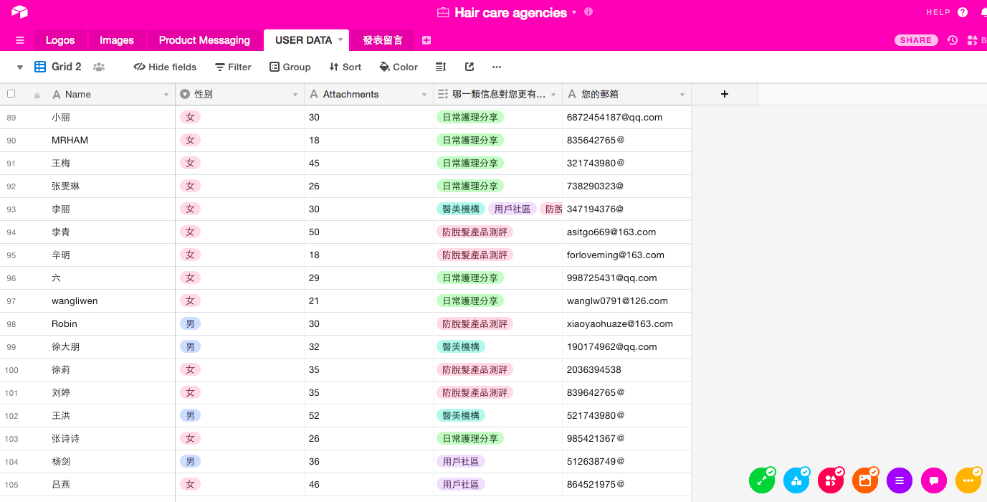

*Figure 23*: *Airtable—User Data*

**9.0 Conclusion**

Based on the discussion above, I have gained a clear understanding of the habits, interests, regions of my target users. So far, the website has reached certain amount of users as the overall page view has reached 9246, and 105 of them have filled in the form and provided me with personal data.

However, limitations still exist as the conversion rate is not as satisfying as I expect. To further improve my website, I will try harder to add more attractive features to encourage people sign up to join our membership. Hope in the coming future, more functions will be achieved and I can start to promote some products on my website.

**Evaluation Report**

Siying Tang (1155111650)

It is hard to believe that I have accomplished so much throughout such a short semester!

As a student majored in linguistics, I have never imagined that one day I could create my personal website through coding. I would like to extend my most sincere thanks to Professor Bernard, without whom I could never be so proud to demonstrate my work to my parents and friends.

But honestly, the course is not easy to handle. Although being excited to learn new things, I also feel so stressed on every Monday night, as I am afraid to make mistakes on a little part of the coding process. Therefore, thanks to coding, I correct my bad habits of being careless and find myself more devoted to every thing that I am working on.

Except basic coding skills, powerful tools including Google Analytics, Airtable, Parsehub, etc. provide me with great efficiency in dealing with data. I really enjoy the process of figuring out the most effective way to visualize the data I collect from different platforms.

However, I also have many regrets as there are still some defects of my projects. Due to the limited time, I cannot make it the best as I expect. I will keep working on it, and see how far I can achieve.

Last but not least, it is really a privilege to spend such a productive semester with dear Professor and classmates. Hope I can learn more in next semester!